Task

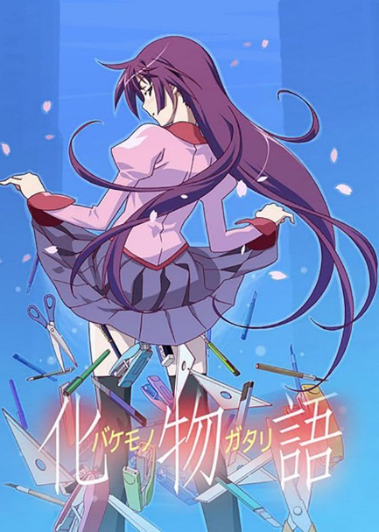 Being the second best selling anime TV series ever, many anime fans have included the “monogatari” series in their “to-watch” list. However, only very few people actually enjoyed the series.

Figure 1: Bakemonogatari poster

Monogatari tells the story about the protagonist Araragi helping many other people who suffer from effects of kaiis, which include Japanese traditional monsters and gods, and how Araragi grows and develops as he goes through different challenges. The reason why the series is so popular in Japan, but no over seas might be because of the large amount of Japanese cultural aspects included in the series: the unique “kanji” writing system that Japanese uses and various aspects of the tradition Japanese religion system.

The original monogatari light novel uses long dialogues and lengthy descriptions of Araragi’s thoughts frequently. If these were to be read in the anime, it would make the anime boring, as vocalizing the dialogues and thoughts would take longer than the already long reading time. The director uses a trick to solve this problem: he often flashes empty shots with only kanji to grab the reader’s focus.

Figure 1 is an instance when kanji is flashed in a long conversation. The shot is not only stationary, but also black and white. Therefore, it contrasts with the colors and movement in anime to grab the audience’s attention.

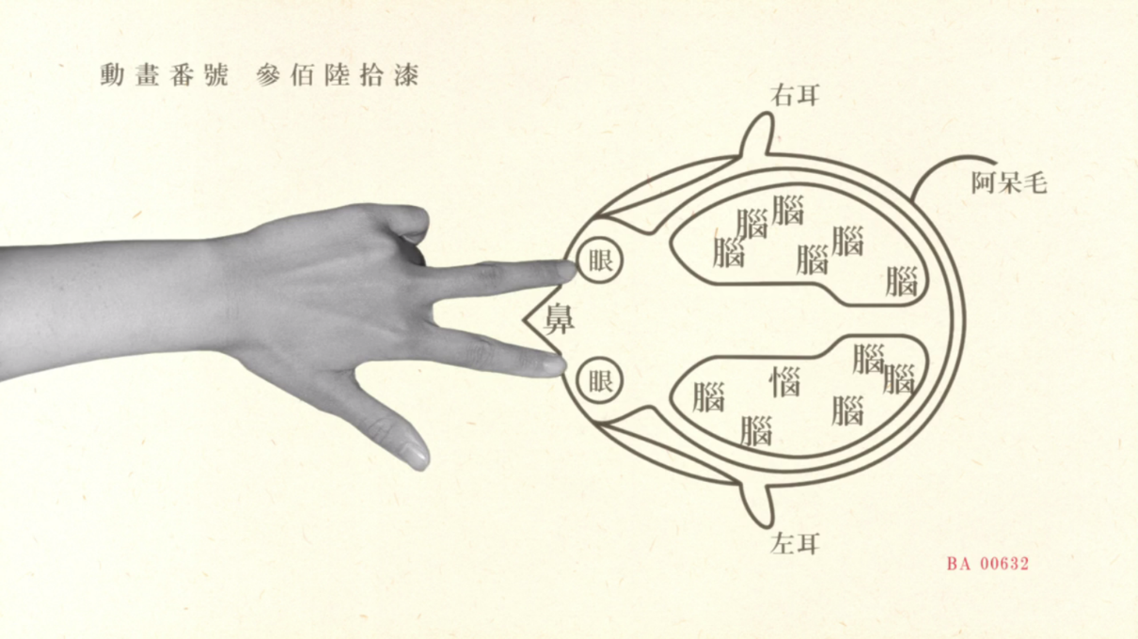

Figure 2: real life pictures and kanji are often flashed to catch the audience’s attention.

While the flashing kanjis draw the audience’s attention, it also easily distracts them from the conversation they already do not want to pay attention to. To avoid this, the kanji flashed on the screen is connected with the specific scene which it interrupts, ensure the reader stays on track. Since kanji is ideographic, with each character representing a different concept or idea, it allows the script to be read quickly. This characteristic is exploited by the anime by only showing the kanji in a short amount of time, leaving only enough time for the audience to roughly recognize the text and its meaning, and switches back to the original scene before the reader can recognize the pronunciation of the word, creating a subtle reminder of the background without distracting the audience too much from the original context.

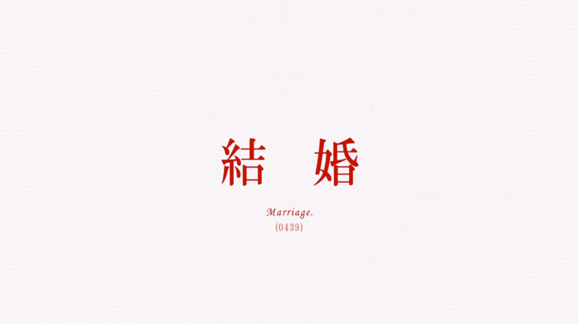

Figure 3: An example of when monogatari flashes kanji on the screen for a short amount of time

The kanji on the figure 3 means “marriage”, which can also be seen from the subtitles, and it is inserted within a conversation between Araragi and his girlfriend about Araragi’s intentions for marriage. The strong contrast between the red colored text and the white background pull the audience’s attention on the text.

This trick, however, this trick does not work for English. English texts are phonetic with each character representing a different sound. Thus English text will need to be translated into sound before an interpretation. This not only breaks the subtleness, but also takes longer to read, making this trick infeasible with English text.

Similar to the cut scenes that catches the attention of the audience, translation also destroys the homonyms created by the author. Homonyms are words that have multiple meaning, and since many kanjis have similar pronunciation, monogatari creates a wide range of homonyms, which each serve a different purpose.

The name of the first season of monogatari “Bakemonogatari” (化物語) is a homonym. The kanji used for bake have the meaning of change, while the rest “monogatari” can be viewed as one word meaning “story”. Together, they form the theme of the series: how people grow up, change and learn to face challenges.

The title can also be viewed a different way, with the first two kanji put together as a word “bakemono”, which are the traditional monsters in the Japanese culture. The last kanji is then interpreted by itself, which while having the dictionary definition of “word, language” are also used commonly as the short form for the word “story”. This interpretation of the title summarizes the series, since it is about Araragi helping various others from kaiis.

The English translation of the title kept the original Japanese name, “monogatari”. This takes away all of the meaning of the title, as the purpose of a translation is so that people of other languages can understand the meaning of the text. With the majority of the audience unaware of the meaning of Japanese, keeping the title Japanese will take away all the information which the title provides to the average English audience.

Homonyms are also used on the names for the kaiis. For example, the “heavy stone crab” (omoshi kani) appears in the first episode, and have taken away the weight of a girl, Senjougahara. The name of this kaii is a play on words. Kani, which means crab in Japanese, sounds similar to kami, which means god. So the anime set the crab as a mythological god in the mountains of Kyushu.

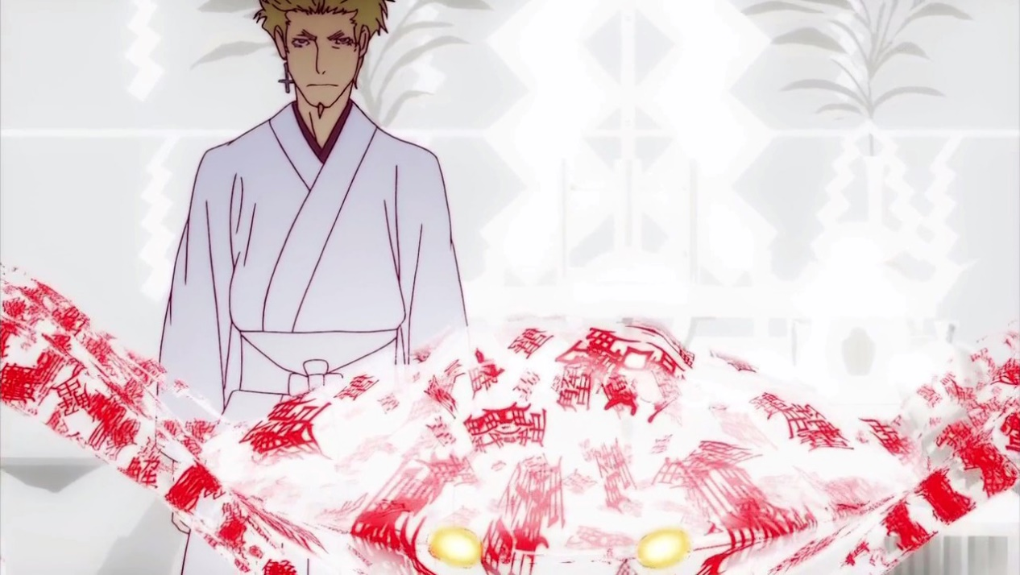

Figure 4: Heavy Stone Crab (Omoshi Kani)

The crab took away the girls weight, because it has the word “omo” in its name, which not only stands for heavy, but also weight. The word “omo” also have another meaning, which has a similar meaning to sentiment when used as an adjective. This is significant because this is alluding to senjougahara’s past. The reason why she is affected by the crab is because her past experiences. Her mother joined a cult, which ruined her family when she was young. She tried to escape her sentiments toward her mother after his mother and father divorced, so she made a deal with the heavy stone crab to take away her weight and her “omo”.

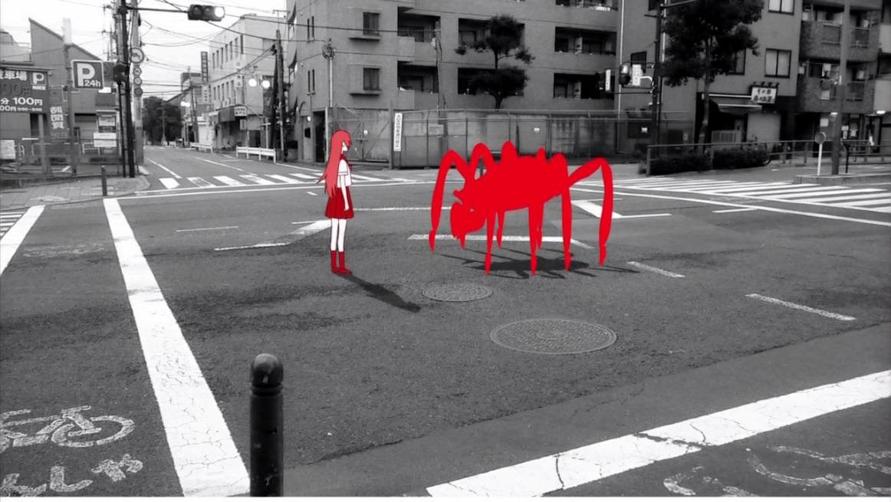

Figure 5: Senjougahara’s childhood encounter with the Heavy Stone Crab

This makes the crab a symbol for her actions of trying to escape the emotions of her past memories instead of facing them. This makes her actions of defeating the crab symbolically representing her growth, and how she started to face the emotion in her past memory instead of running away from the negativity.

This symbol however is weakened in the English translation, as there are no longer a direct connection between the heavy stone crab and what it represents. The weakening of such a critical symbol weakens the theme which is the message of the series, making the entire anime less powerful.

The idea of kaiis itself is a mind twister for many people who do not understand the Japanese culture. Unlike in the western culture, gods in Japan are often used to refer to the natural spirits, which often does not even have a set appearance. They do not ask for worship, and a wish is enough for a response. Without understanding of this part of culture, Senjougahara’s casual interaction with a god may be confusing to the audience, distracting them from understanding the theme of the show.

The translation process takes away many unique aspects of the series, such as techniques used to catch the attention of the audience, and the many homonyms present through out. This causes the series to loose many of its unique selling points, which explains its low popularity overseas. However, with various aspects of the Japanese culture such as kanji and the religion system mention through out, it serves as a great attraction for other people to learn more about Japanese culture.